Integrating Acceleration

Justin Dyer

1. Data Acquisition:

To acquire data, Logan recorded me driving and we planned to accelerate to about 35 mph. The video below is Logan and I acquiring data:

1. Acceleration Plot and Signal Conditioning:

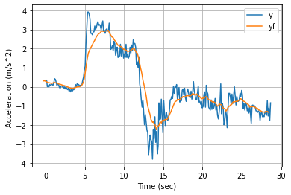

Plotting the data, I received a plot similar to the one shown above, I applied a simple data filter to it to adjust for peaks. I then subtracted the data by 0.5 to adjust for phase shift.

1. Integrating Acceleration

Below is the plot I received from integrating the acceleration data:

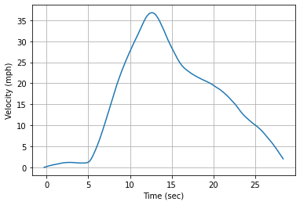

This plot shows the velocity that we accelerated to, to roughly 37mph, which is relatively close to our expectation.

1. Integrating Velocity

Below is the plot I received from integrating the velocity data:

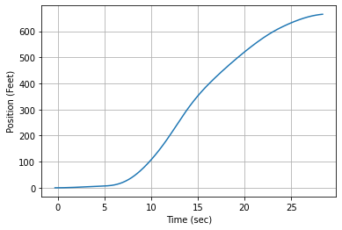

The plot above shows the distance traveled in our experiment. This came out to be roughly 675 feet. This is fairly accurate to what I would guess we traveled.